3.SET UP AND CONFIGURE GITHUB ACCOUNT

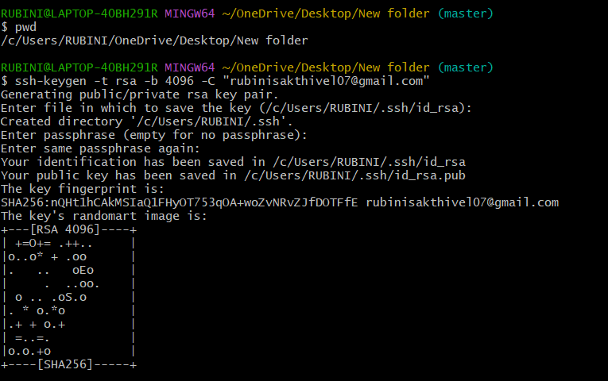

Creating SSH-key and adding it to GitHub

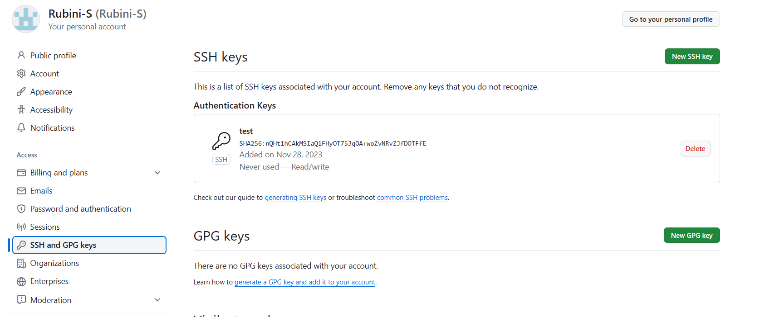

Creating a repository in my GitHub account

